ESCOLA |  |  |  | DATA |  | ____ /____ / ____
ALUNO
PROFESSORA |  |  | ANO |  |  |  | TURMA

COMPLETA AS PALAVRAS COM A VOGAL U.

 |  | 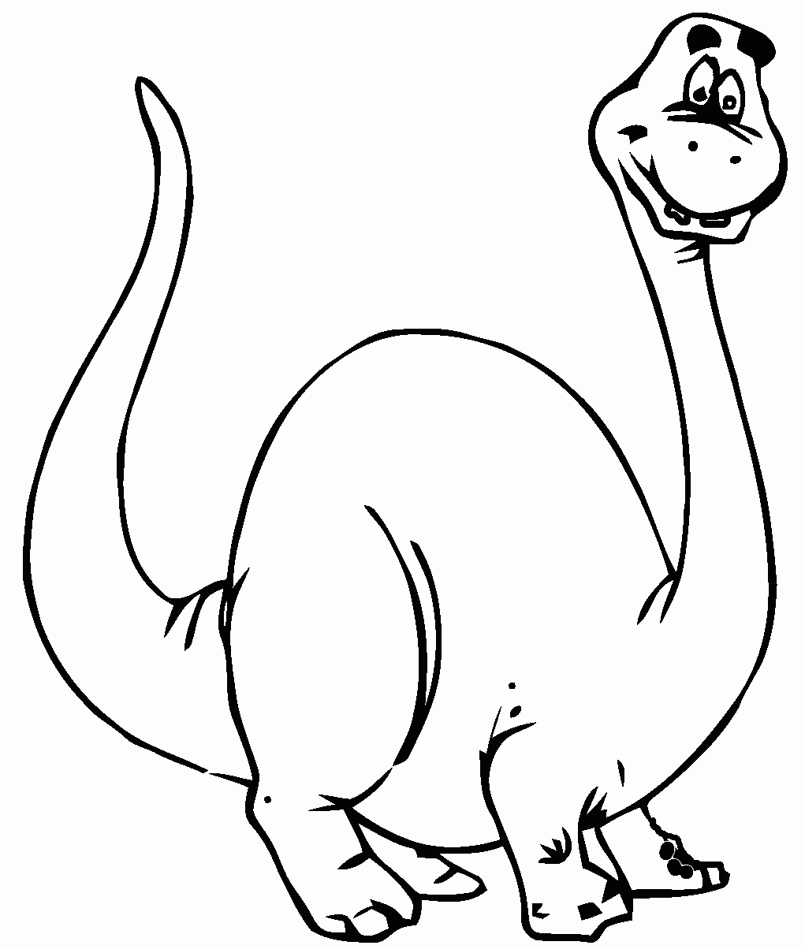
ASTRONA ___ TA |  | DINOSSA ___ RO
 |  | 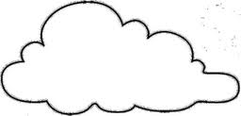
D ___ NGA |  | N ___ VEM
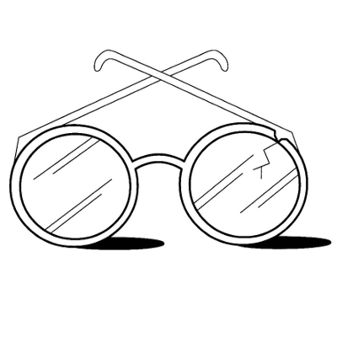 |  | 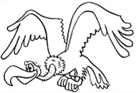
ÓC ___ LOS |  | ___ R ___ B ___

