ESCOLA |  |  |  | DATA |  | ____ /____ / ____
ALUNO
PROFESSORA |  |  | ANO |  |  |  | TURMA

COMPLETA AS PALAVRAS COM A VOGAL O.

ANZ ___ L |  | L ___ B ___
 |  | 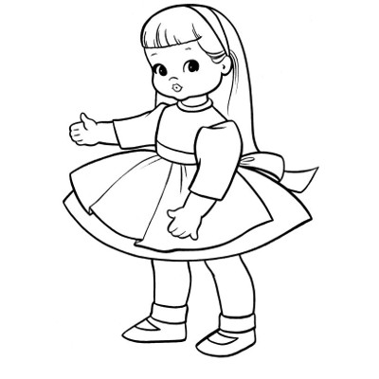
M ___ RANG ___ |  | B ___ NECA
ANJ ___ |  | DIN __ SSAUR ___

