ESCOLA |  |  |  | DATA |  | ____ /____ / ____
ALUNO
PROFESSORA |  |  | ANO |  |  |  | TURMA

COMPLETA AS PALAVRAS COM A VOGAL E.

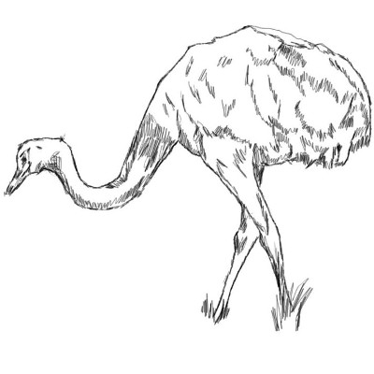 |  | 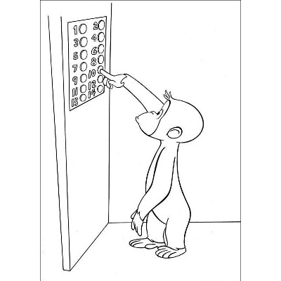
___ MA |  | ___ L ___ VADOR
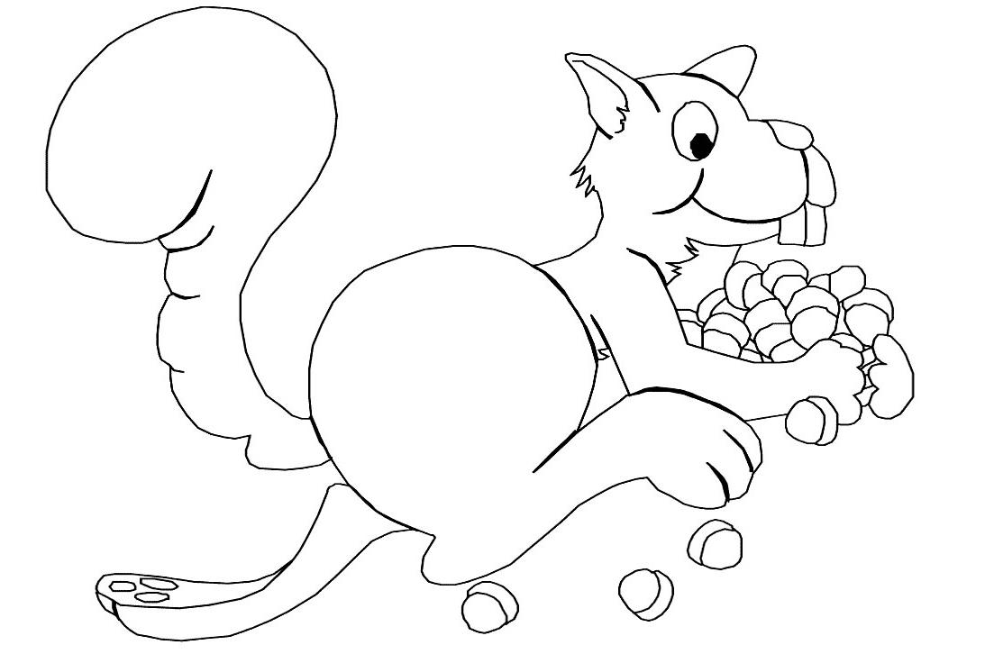 |  | 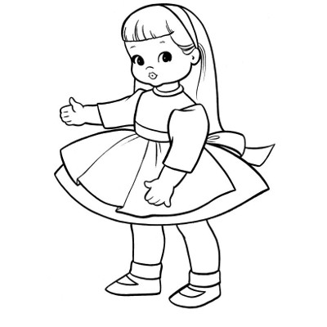
___ SQUILO |  | BON ___ CA
M ___ NINO |  | P ___ IX ___

