ESCOLA |  |  |  | DATA |  | ____ /____ / ____
ALUNO
PROFESSORA |  |  | ANO |  |  |  | TURMA

COMPLETA AS PALAVRAS COM A VOGAL A.

 |  | 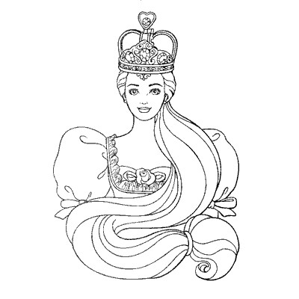
___ NZOL |  | R ___ INH ___
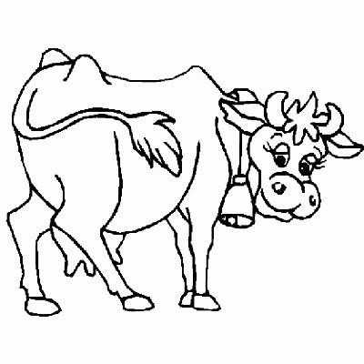 |  | 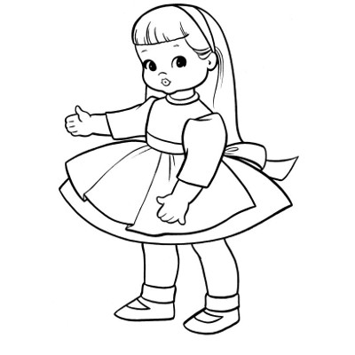
V ___ C ___ |  | BONEC ___
 |  | 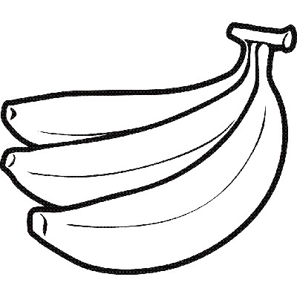
___ NJO |  | B ___ N ___ N ___

