ESCOLA |  |  |  | DATA |  | ____ /____ / ____
ALUNO
PROFESSORA |  |  | ANO |  |  |  | TURMA

LEIA O ALFABETO.
A | B | C | D | E | F | G | H | I
J | K | L | M | N | O | P | Q | R
S | T | U | V | W | X | Y | Z

COMPLETE O ALFABETO.
A |  | C |  | E |  | G |  | I
 | K |  | M |  | O |  | Q
S |  | U |  | W |  | Y

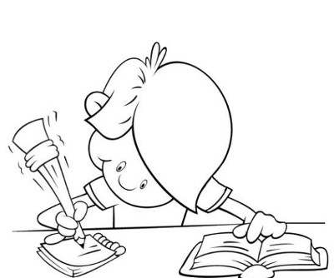
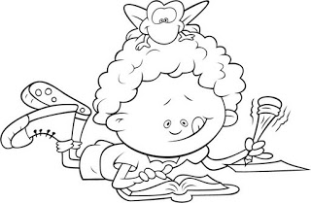
COMPLETE NOVAMENTE.
 | B |  | D |  | F |  | H
J |  | L |  | N |  | P |  | R
 | T |  | V |  | X |  | Z

